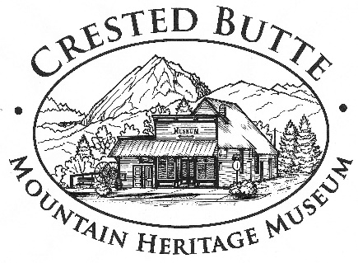

Crested Butte Mountain Heritage Museum
Events and Marketing Coordinator Job Description

Organization Background:
The mission of the Crested Butte Mountain Heritage Museum (CBMHM) is “to preserve and share the uniquely diverse cultural history of the Gunnison Valley. We make the past a living part of the future.” Since its founding in 1991, the CBMHM has been dedicated to preserving local history. It started as a grassroots organization seeking to save historic treasures such as the Crested Butte Water Tower and gradually expanded its mission to preserving and sharing the history of the Gunnison Valley. In 2003 the CBMHM relocated to the historic Crested Butte Hardware Store, affectionately known as Tony’s Conoco. In addition to sharing local history with residents and visitors through our evolving exhibits, the CBMHM maintains an ever growing collection of local historic artifacts and offers educational programs including student field trips, Historic Walking Tours, Historic Pub Crawls and a Speaker Series to the public.

Summary of the Position:
- Responsible for coordinating Museum events and tours; developing and implementing marketing plans; and coordinating volunteers
- Work in collaboration with the Board and Staff to promote and raise funds for the Museum
- Work in conjunction with the Board and Staff to develop the strategic directions and establish initiatives to fulfill the mission of the Museum
Qualifications:
- Excellent interpersonal and communication skills with demonstrated ability to be a strong team player as well as speak and write clearly and persuasively
- Excellent organizational, time management, and follow-up skills: high sense of urgency, ability to work independently, juggle multiple priorities and creatively solve problems
- Strong computer skills, including experience working with social media platforms and Microsoft Office applications; proficiency in or willingness to learn programs such as Wordpress, Mailchimp and Past Perfect
- A passion for preserving and sharing the history of the Gunnison Valley
- Prefer a minimum of 2 to 4 years’ experience in a special events, marketing and volunteer coordinator position
Specific Duties Include:
• Coordinate all aspects of Museum events and programs, including planning, working with contractors, ticket sales, implementation and follow-up
• Coordinate event and program publicity, including public relations, advertising and collateral material design, production and distribution
• Coordinate Museum volunteers, including staffing, recruitment, training and stewardship
• Annually develop and implement events and marketing plans, budgets and materials
• Work with the Board of Directors and Executive Director to cultivate and expand sponsorship development and fulfill silent auction, raffle prize and in-kind donation solicitations for events
• Work with the Board of Directors and staff to develop new event and program ideas
• Development and maintenance of website
• Maintain and broaden social media presence
• Maintain event photo archive
• Actively participate and staff committees as necessary and appropriate
• Other duties as assigned
Hours: Total 780 per year / Average 15 hours per week

